
Database Management I (420-J10-HR)

Happy Valley Kennels Project - Assignment 2 - Logical Data Model and Attribute Definitions (HVK Group Project)

Date assigned: Friday, September 26th
Date due: Thursday October 9th @ 11:50PM (final, see milestones table)
You will be given time during one lab period, on Friday October 3rd , to work on this assignment. You must organize other time to work with your team to complete the assignment.
A progress submission will be required at the end of the lab block used for the assignment.
Learning Objectives
After completing this assignment, the student will be able to
- Resolve many-to-many relationships;
- Determine candidate, primary and alternate key attributes;
- Define attributes;
- Distinguish between:
  - simple and composite attributes;
  - stored and derived attributes;
  - singular and multi-valued attributes;
  - mandatory and optional attributes; and
- Recognize when to use subtype/supertype relationships in data modeling.
References:
- The Happy Valley Kennels Case Study & Price List
- 420-J10 N03 & N04
- Systems Analysis Assignment 1- HVK User Stories
To Start:
- Create a folder in your team folder called teamn_A02_Logical_Data_Model for this assignment.
- A template is provided for the Entity Attribute table. Rename it to teamNumber_A02_Entity_Attribute
- Your professor will provide a brief walkthrough of the steps needed to do this assignment.

To do:
Task
- Prior to Friday October 3, you’ll get feedback on your A01 Conceptual Model. You must address the concerns raised.
- Read the appendix on our naming standards for Entities and Attributes. Be sure to follow this standard
- Follow our process to migrate to a logical model:
  - Remove all Many:Many relationships
  - Identify keys
  - Identify attributes
- Understand the milestones (what needs to be done by when)

To be handed in:
- Updates to A01 based on feedback
- The teamNumber_A02_Logical_Data_Model folder should be in your Teams folder.
- The Entity Attribute spreadsheet: teamNumber_A02_Entity_Attribute.xlsx
- The exported file from ERDPlus of your Relational schema in the A02 folder: teamNumber_A02_LogicalModel.erdplus
- A screen snapshot of your final model: teamNumber_A02_LogicalModel.png

Hints

Note: For your Logical model, create a Relational Schema diagram in ERDPlus, this is where you’ll flesh out your logical model into a physical model.
To hook up your tables, you must use the Connect option in ERD Plus from the PK to the FK entity. For example to connect Student to Loan, I selected Connect, click on Student, then Loan. The StudentID FK appears in Loan.
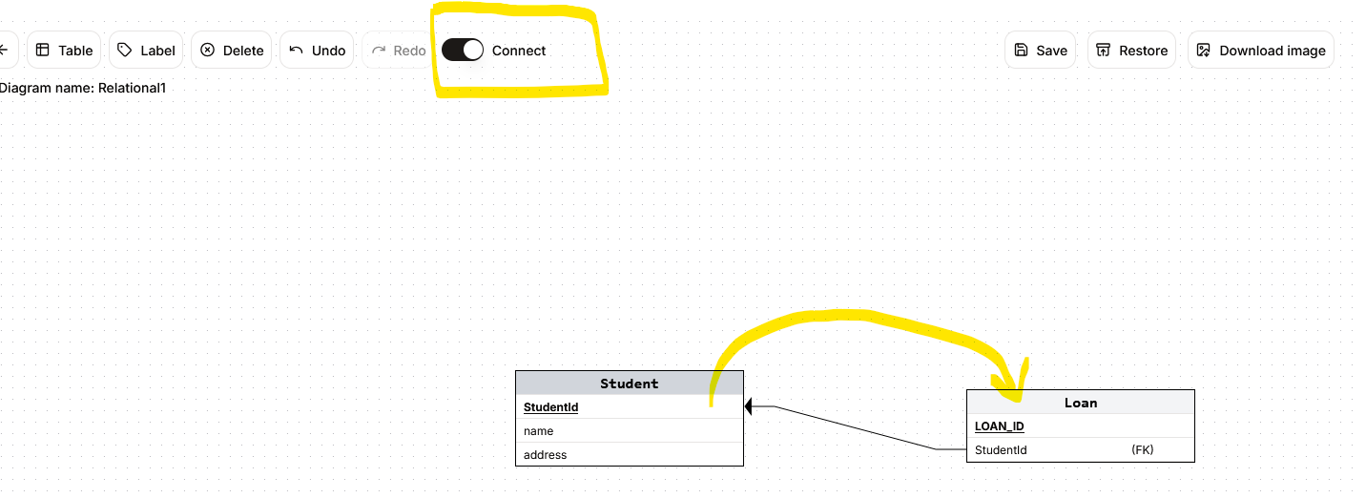
For this assignment, I will not be looking at the data types of each attribute. You’ll be determining the data types for each attribute in Assignment 3.

Deliverables and Dates
Friday October 3 | Updated Assignment 1 (end of lab session)  Initial Logical Model showing Tables, PKs, FKs, Associative Entities (ERDPlus and PNG file)  Initial Entity Attribute spreadsheet  (end of day; 23h50) | Workshop provided during lab hours
October 9, 23h50 | Final logical model (ERDPlus file, PNG)  Final Entity Attribute spreadsheet

Appendix 1: Naming Conventions

We will be following the conventions used in the Microsoft sample databases (i.e. as per our J10_DB1 sample database)

General Naming Conventions
PascalCase – first letter of each word is capitalized (i.e. ‘InvoiceDate’)
By default, SQL Server is not case sensitive
Ideally full words (not abbreviated) for ease of reading (i.e. ‘Customer’, not ‘Cust’)

Entity Naming
Table names are singular (not pluralized)
Use nouns that describe what is stored in the column. Example: FirstName, Address, Email, Phone . Avoid using words that are just data types like text or date.

Attribute Naming
Where Entity is the entity name, and the attribute name is typically from a class/domain from the list provided below, if appropriate.
For more information on Data domain, see: https://en.wikipedia.org/wiki/Data_domain

Standard Domain types and descriptions:

Class | Description
Address | The street address, city, postal code and province
City | The name of the city in an address
Date | A calendar date that can specify YYYY MM DD
Description | A brief description
Email | The email address of a person or organization
Fax | The 10-digit fax number of a person or organization
FirstName | The given name of a person
LastName | The surname of a person
Name | The name by which something is called. In the case of a person, it may be subdivided into first and last name and, optionally, middle name or initial.
Number | An identifying number. When used as the primary key for an entity, it is prefixed with the entity name
Phone | The 10-digit telephone number of an individual or organization
PostalCode | A 6-character Canadian postal code
Price | The monetary cost
Province | A standard 2-character Canadian province abbreviation
Quantity | A numeric quantity
Status | Status, with definition of meaning in context
Street | The street number, name and optional apartment number in an address or a box number or a rural route number
Webpage | The home page URL of a person or organization

For a template on how to capture the attributes see the file “A02 Entity Attribute Template”

PK/FK Naming
Ideally, have the table name prefix a PK so that if it’s used as a FK, it is automatically understood as to which table it references.

Examples:
PetId, ReservationId

